005 Angular2 - adding bootstrap

Angular2 Kata List – Blog Page

[TypeScript Kata List on GitHub](https://github.com/robertdunaway/katas-typescript)

# Duration

[minutes]

# Brief

[subject of kata]

### For More Information

BING/GOOGLE: “Angular2 ”

Read eBook: <https://www.ng-book.com/2/>

# Instructions

Get tutorial folder or the entire katas-angular2 repo.

Open the [before/*.sln] file and execute the kata.

Feel free to execute this kata multiple times because repetition creates motor memory.

# Github

* Before (start kata with this)
  + [https://github.com/](https://github.com/robertdunaway/katas-typescript/tree/master/001%20TypeScript%20-%20declare%20variables)
* After
  + [https://github.com/](https://github.com/robertdunaway/katas-typescript/tree/master/001%20TypeScript%20-%20declare%20variables/after)

# Kata

## Web link for Bootstrap 4 alpha

<http://v4-alpha.getbootstrap.com/>

* The css is required but not the JavaScript because we’ll be using ng2-bootstrap.

## ng2-bootstrap

<http://valor-software.com/ng2-bootstrap/index-bs4.html>

Install NPM packages

npm install ng2-bootstap --save-dev

npm install [bootstrap@4.0.0-alpha.2](mailto:bootstrap@4.0.0-alpha.2) --save-dev

Add the required files to out gulp task, libs, to copy to wwwroot.

, 'node_modules/**//bootstrap/dist/css/bootstrap.min.css'

, 'node_modules/**//ng2-bootstrap/bundles/ng2-bootstrap.min.js'

Add references to the index.html file.

<link href="../lib/bootstrap/dist/css/bootstrap.min.css" rel="stylesheet" />

<script src="../lib/ng2-bootstrap/bundles/ng2-bootstrap.min.js"></script>

Running the application, we can already see some changes. You’ll notice the font is different and some spacing has changed.

The top is before and the bottom is after.

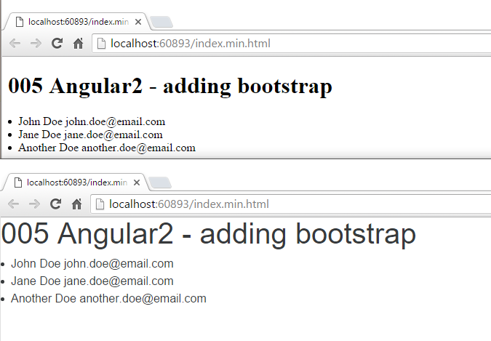

Let’s go ahead and add a couple controls to make sure things work.

**Add a calendar control**

This requires moment.js so we’ll need to add this npm package.

npm install moment --save-dev

Update the lib task to copy moment.js to wwwroot.

, 'node_modules/**//moment/min/moment.min.js'

Update the system.js config in index.html.

# Next

Take a few minutes and imagine more examples.